**RF USERS MANUAL**.

**How it works?**

Login your account

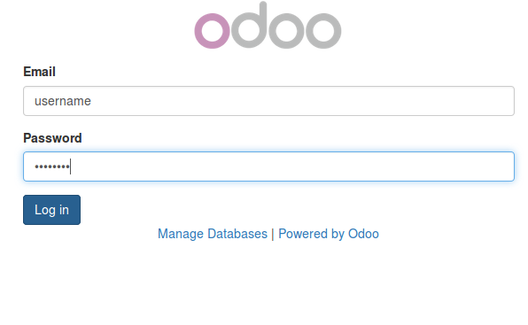

Once logged in, you can configure your account setting under Preferences

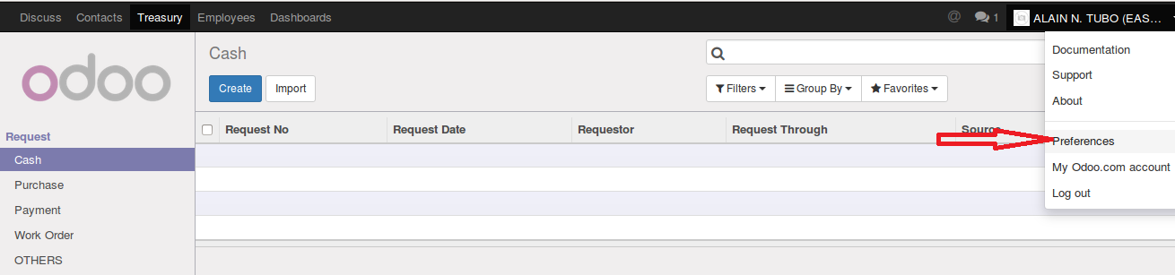

For multi-company users, you have the option to select what company you’ll login as.

You can only use one(1) company at a time

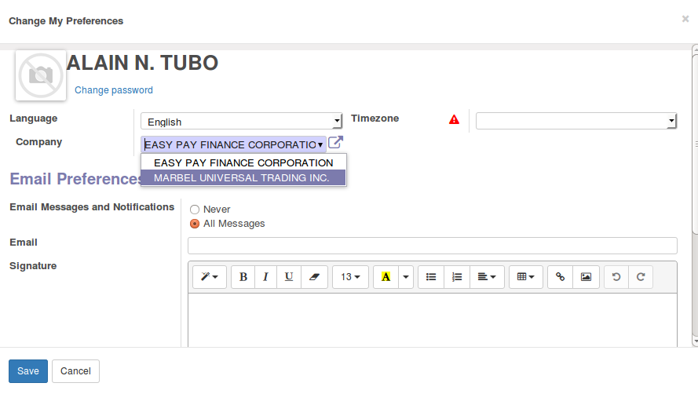

1. **How to make a request**

In Treasury>Request, you can select what menu depending on your Request Category

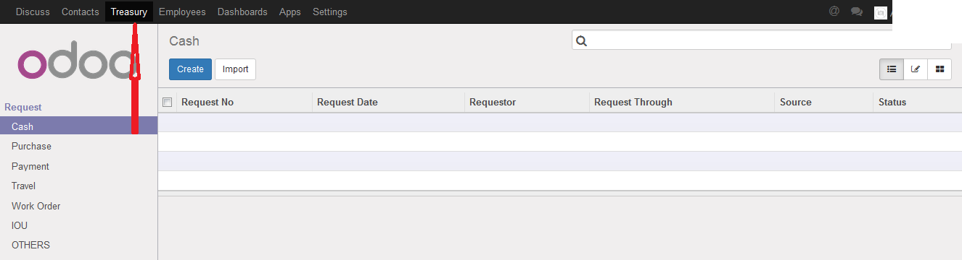

1. As you create a request, fields Company, Requestor and Branch/Department will automatically be filled out

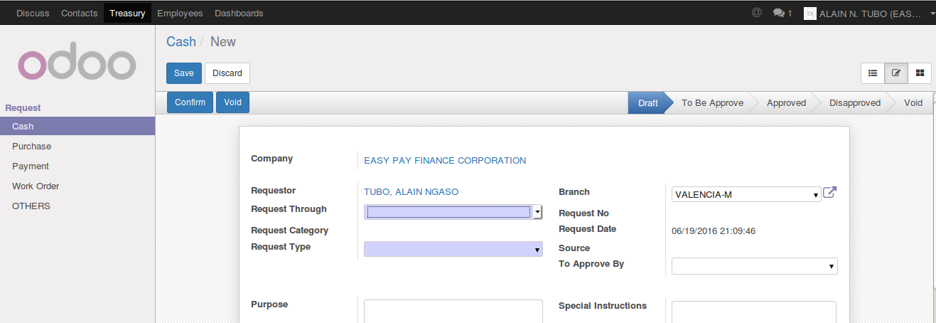

1. Fill Request Through

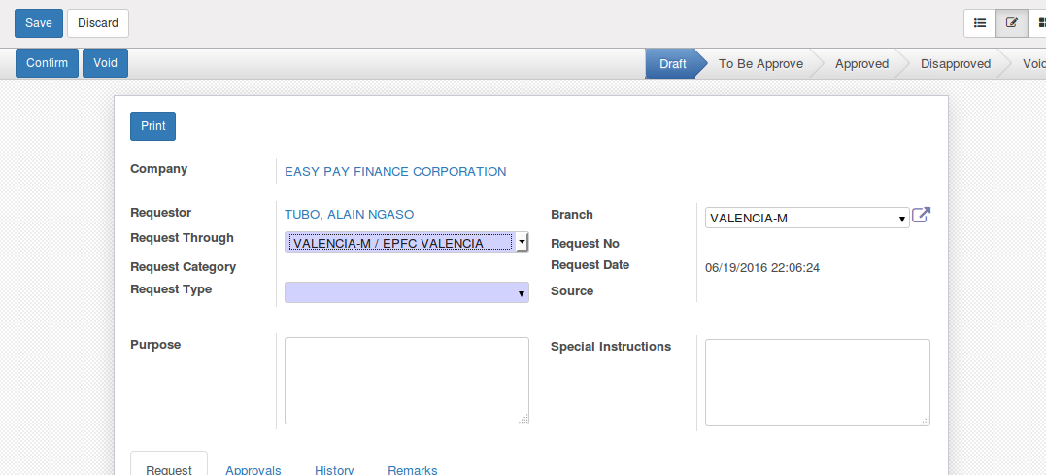

1. Fill Request Type. Once selected, fields Request Category and Source will automatically be filled out

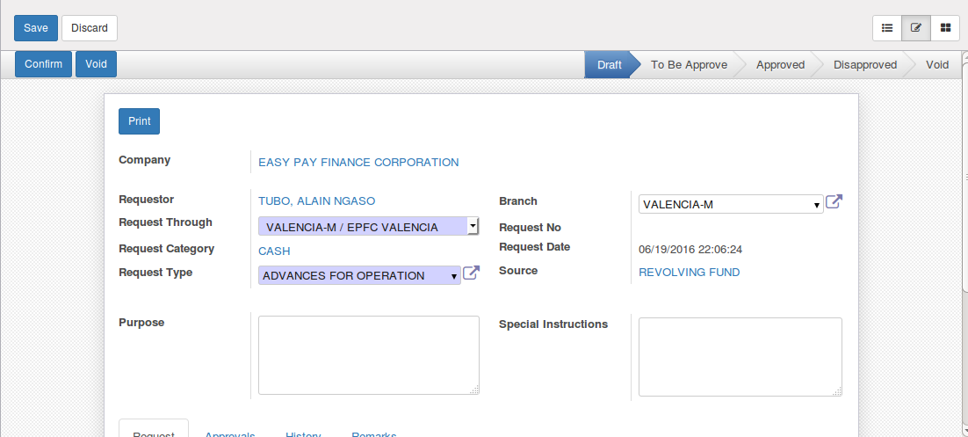

1. Add/Edit/Delete list of items

Click add an item

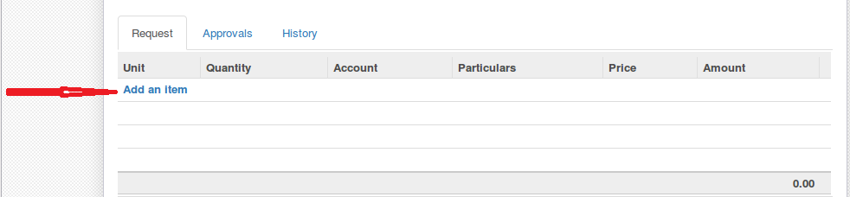

Define items

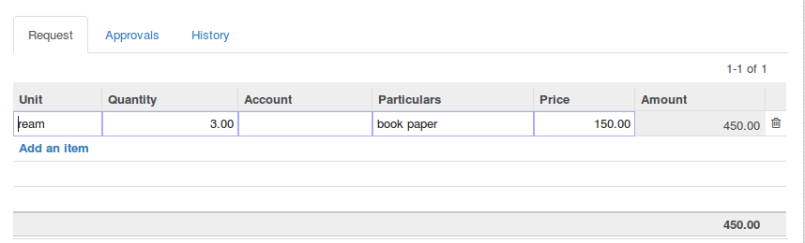

Edit an item. Click the row of item that you want to modify

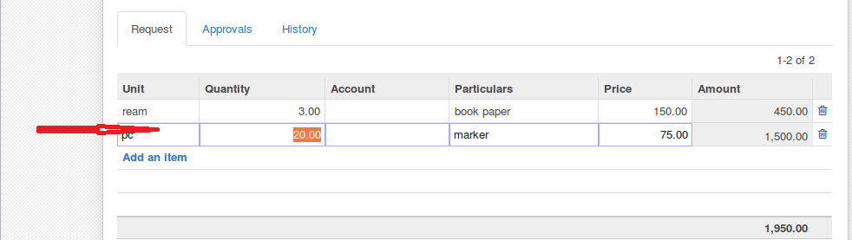

Delete an Item. Click the trash bin icon on the right side of the row you want to be deleted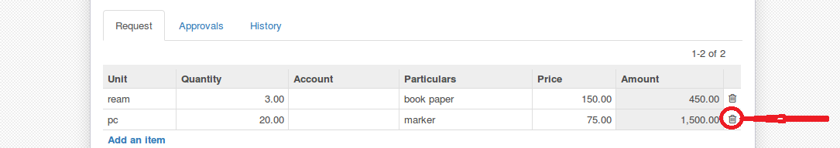

1. Save the record

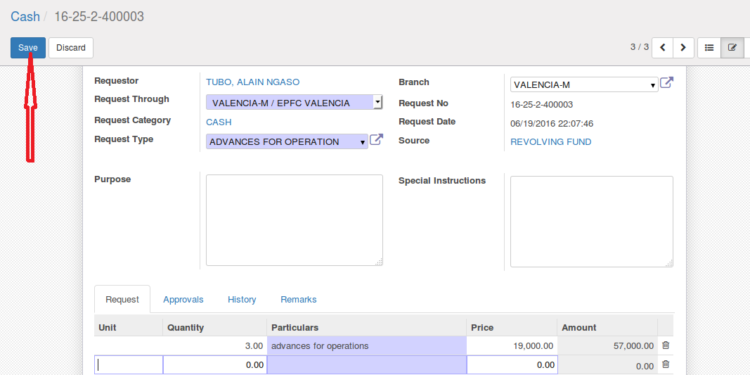

Once record is saved, user can now view list of approvers under Approval Tab. Once approved field is unchecked it means request is still waiting for approval, otherwise approved

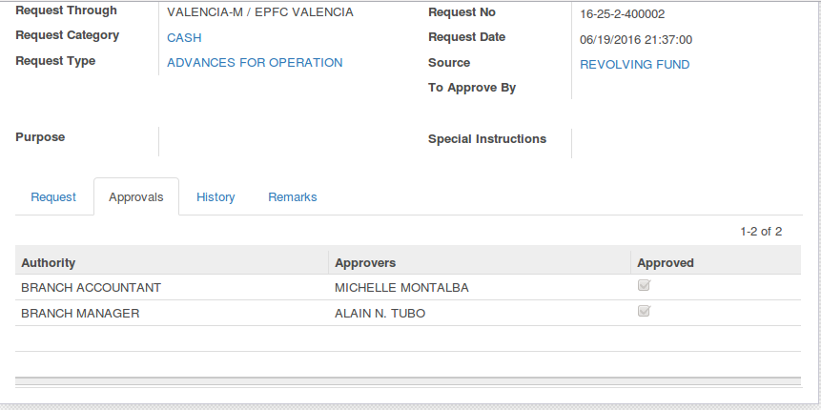

1. Confirm the document. Only the requestor can confirm the document

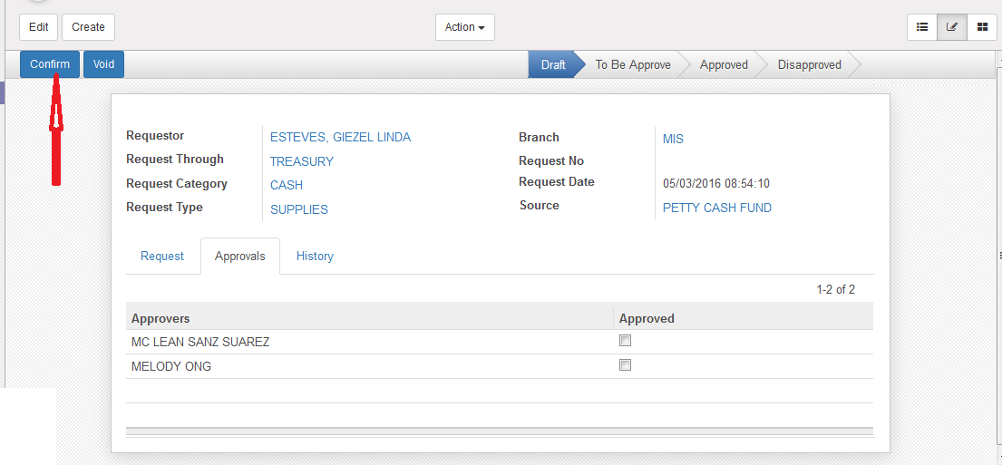

Once confirmed:

* requestor has no privilege to modify the document
* buttons Approve and Disapprove will be available and
* document’s status will be changed to ‘To Be Approve’
* Once state is not ‘Approved’ yet, requestor can still set the document into draft

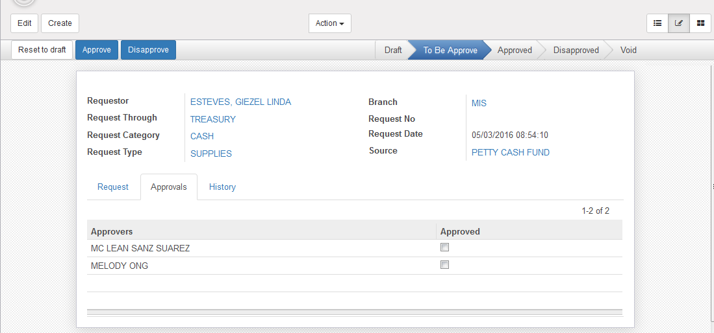

1. Users can also use ‘attachment’ for support documents. 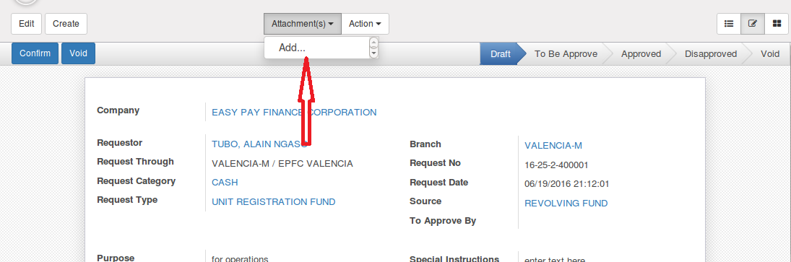
2. Once record state is ‘Approved’, printing option is allowed which can be triggered only ‘ONCE’

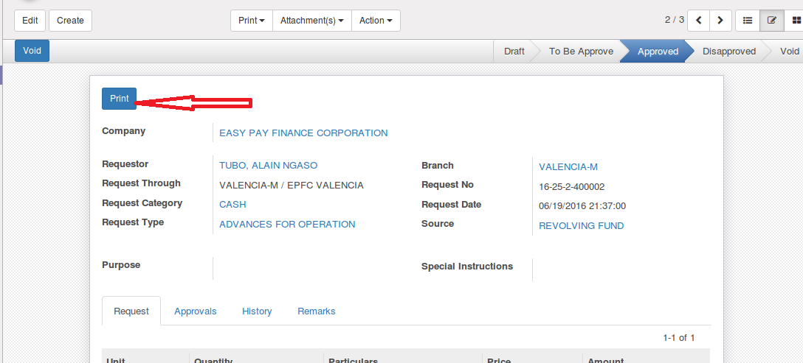

1. Users have the option to filter requests

Options: My Request, Branch/Dept Request, Other Request

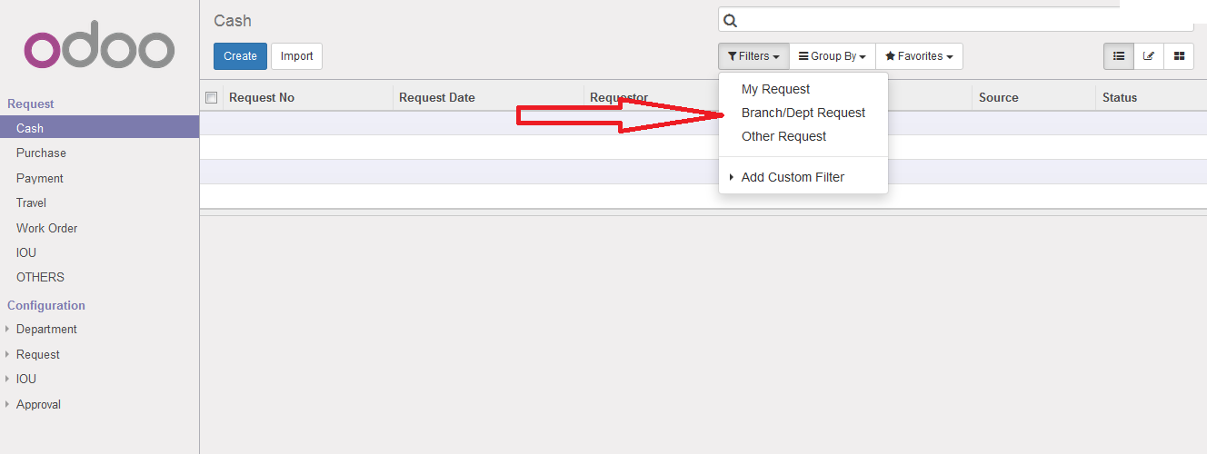

My Request: views list of requests created by the signed in user. Default View

Branch/Dept Request: list of requests created by branch/department of signed in user

Other Request: list of request requested through branch/department of the signed in use

1. **How to approve a request (For Approvers Only)**

Menu: Dashboard>Request>For Approvals

List of Requests are grouped by branch/department. Only request that needs approval of the current logged in user can be viewed in the dashboard

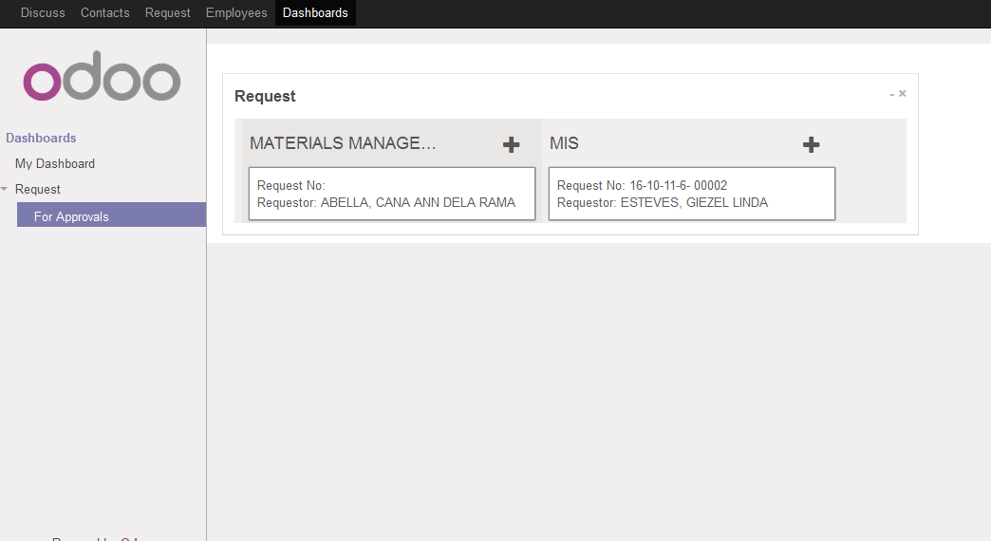

Click Approve. Once the approver approves the record, he/she will not be able to view the document anymore. It will be move to the next approver.

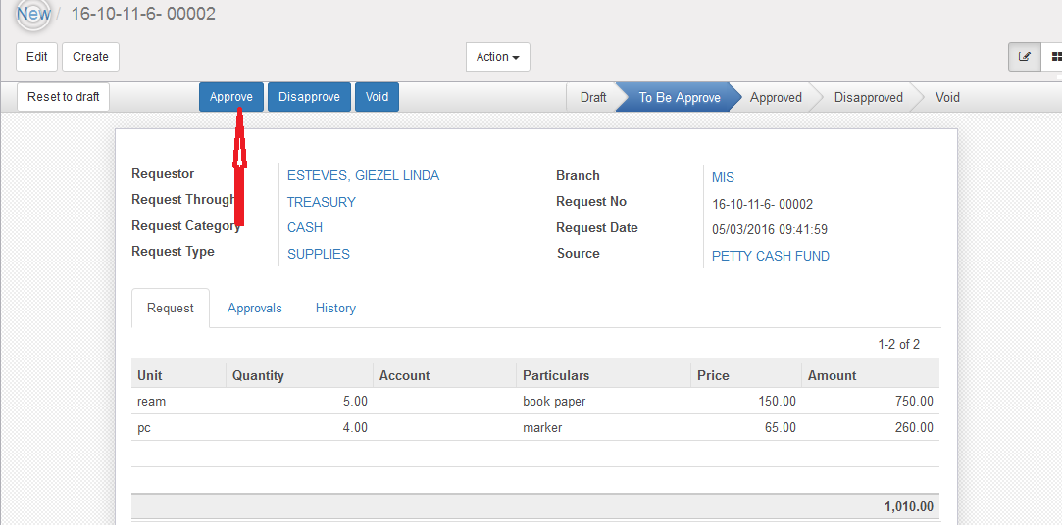

1. **VIEWS**

List View

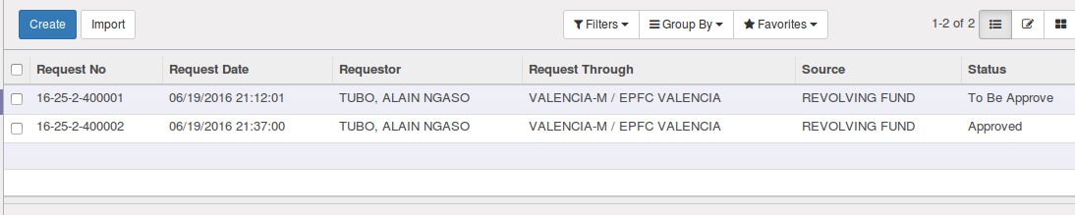

Kanban View

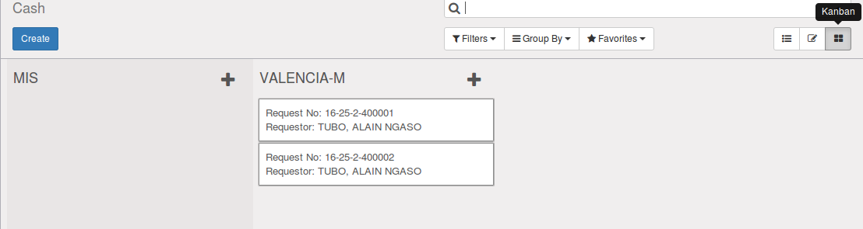

Form View



1. **MENU and ACCESS RIGHTS**
2. Menu

* Treasury>Request

1. Access Rights

|  |  |  |  |  |
| --- | --- | --- | --- | --- |
| **Type** | **Read** | **Write** | **Create** | **Delete** |
| Request User | Yes | Yes | Yes | No |
| Request Admin | Yes | Yes | Yes | No |

1. **Workflow**

Below is the list of states and visibility of the various buttons based on the record state:

CONFIRM

SET BACK TO DRAFT

APPROVE

DRAFT

VOID

DISAPPROVE

VOID

|  |  |  |
| --- | --- | --- |
| STATE | DESCRIPTION | VISIBLEBUTTONS |
| Draft | Initial state of the record | Confirm, Void |
| Confirmed | Record is finalized and ready for Approval. Once confirmed, fields are not editable. | Approve, Disapprove, Set Back to Draft |
| Void | Record will be set to Void | None |
| Approved | Record has been approved. Once record status is ‘Approved’, document can now be printed | Void |
| Disapproved | Record has been cancelled or disapproved | Void |

1. **User Action**

Below is the list of user action available for specific users and its corresponding procedures:

|  |  |  |
| --- | --- | --- |
| STATE | DESCRIPTION | TRIGGERED BY |
| Confirm | Record will be changed to ‘To Be Approve’ and ready for approvals | Requestor |
| Void | Record will be set to void and cannot be used anymore | Requestor |
| Approve | Record has been approved. Once record status is ‘Approved’, document can now be printed | Approver |
| Disapprove | Record has been cancelled or disapproved | Approver |

1. **Fields Visibility**

All fields are visible in all state